

AMERICAN INTERNATIONAL UNIVERSITY-BANGLADESH
Faculty of Science and Technology Department of Computer Science CSC 3215: Web Technologies

Semester: Summer 2025-26 | Group No: 6 | Section: J

Group Members:

SL. | Student ID | Name | Role | Signature
1 | 23-55218-3 | Najiat Islam Rishad | Group Leader
2 | 24-56493-1 | Ryan Ferdous Kabir | Member
3 | 23-53042-3 | Partho Nath Ghosh | Member
4 | 23-55140-3 | Sadia Afrin Ananna | Member
Project Title
EduQuiz
Short Description
EduQuiz is a role-based web application developed using PHP and MySQL. It allows Admins, Instructors, and Students to manage courses and quizzes through a shared login and registration system. Admins manage users and courses, Instructors create courses and quizzes and view student performance, while Students enroll in courses, attempt quizzes, and view their results.
Introduction
Educational institutions need a simple and centralized system for course management and student assessment. EduQuiz provides a single web platform for three types of users—Admin, Instructor, and Student—with separate dashboards based on their roles. The system supports user authentication, course enrollment, quiz creation, automatic scoring, and result tracking.
Background Study
EduQuiz is designed as a lightweight and easy-to-self-host web application. It provides the basic Learning Management System (LMS) functions, including course management, enrollment, quizzes, and result tracking, while remaining simple to develop, deploy, and maintain using standard PHP and MySQL.

ER Diagram
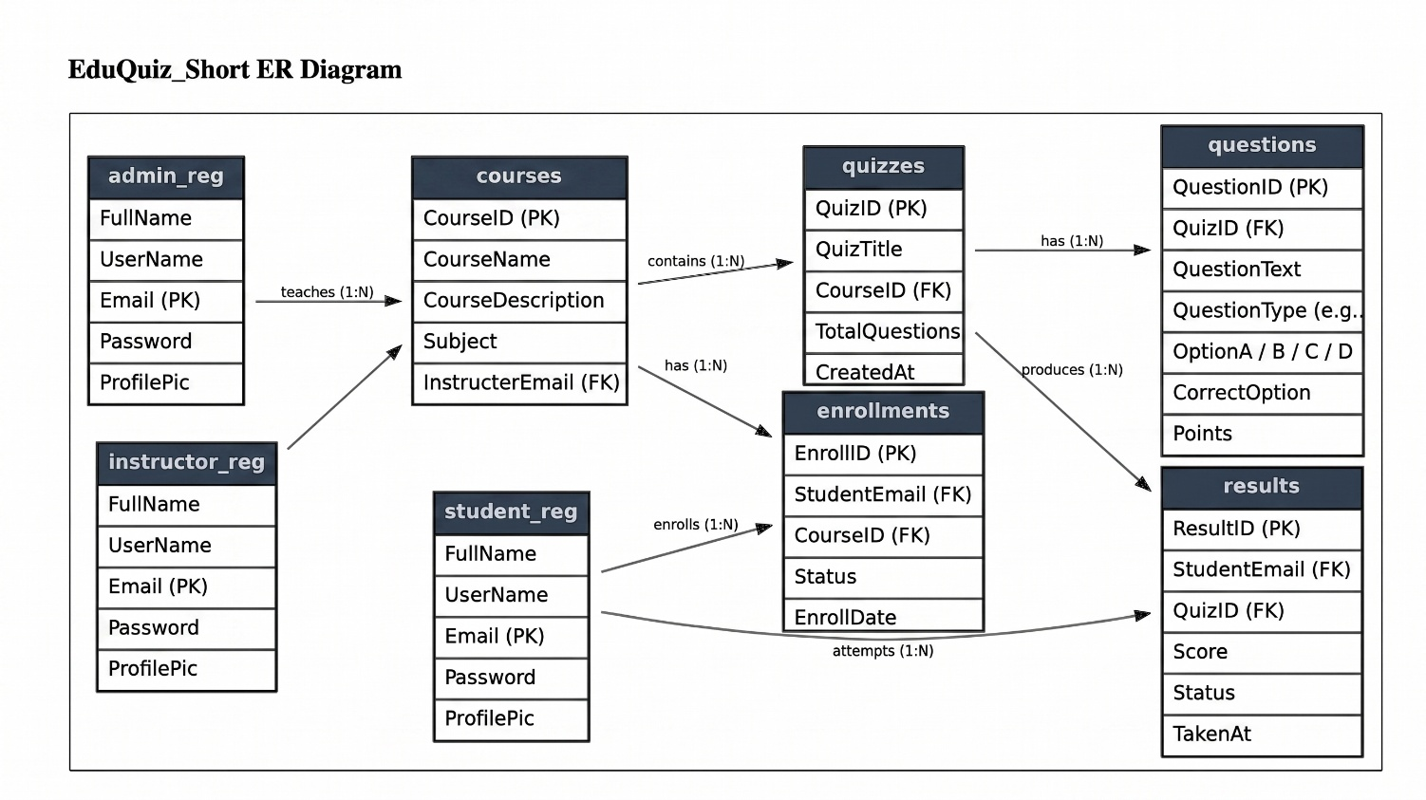
Use Case Diagram
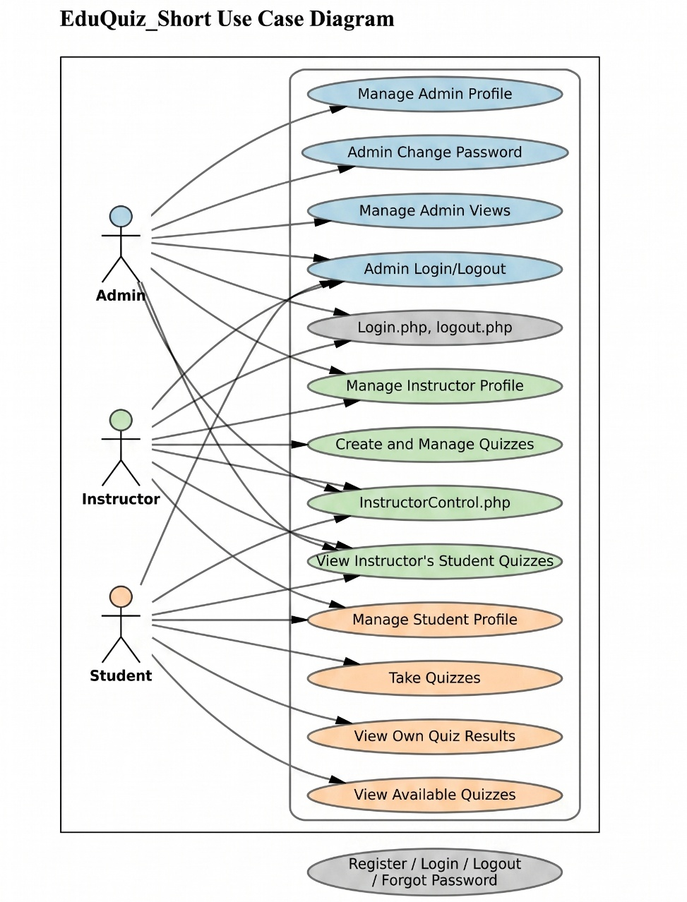
UI (Figma/Sketch)
Mainpage
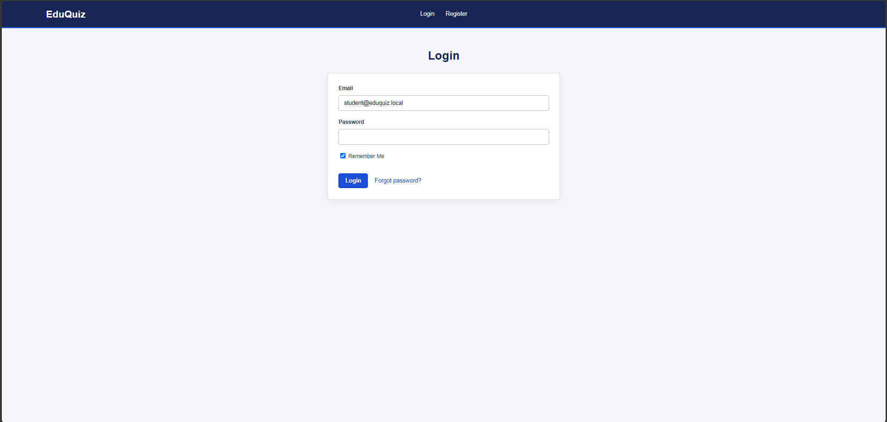

Admin Dashboard
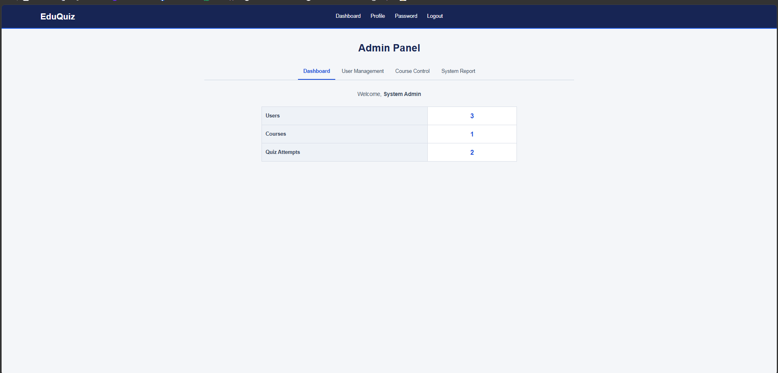

Instructor Dashboard
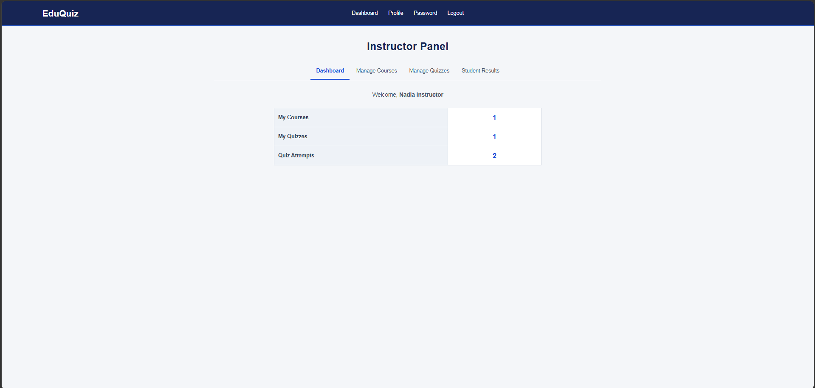

Student Dashboard
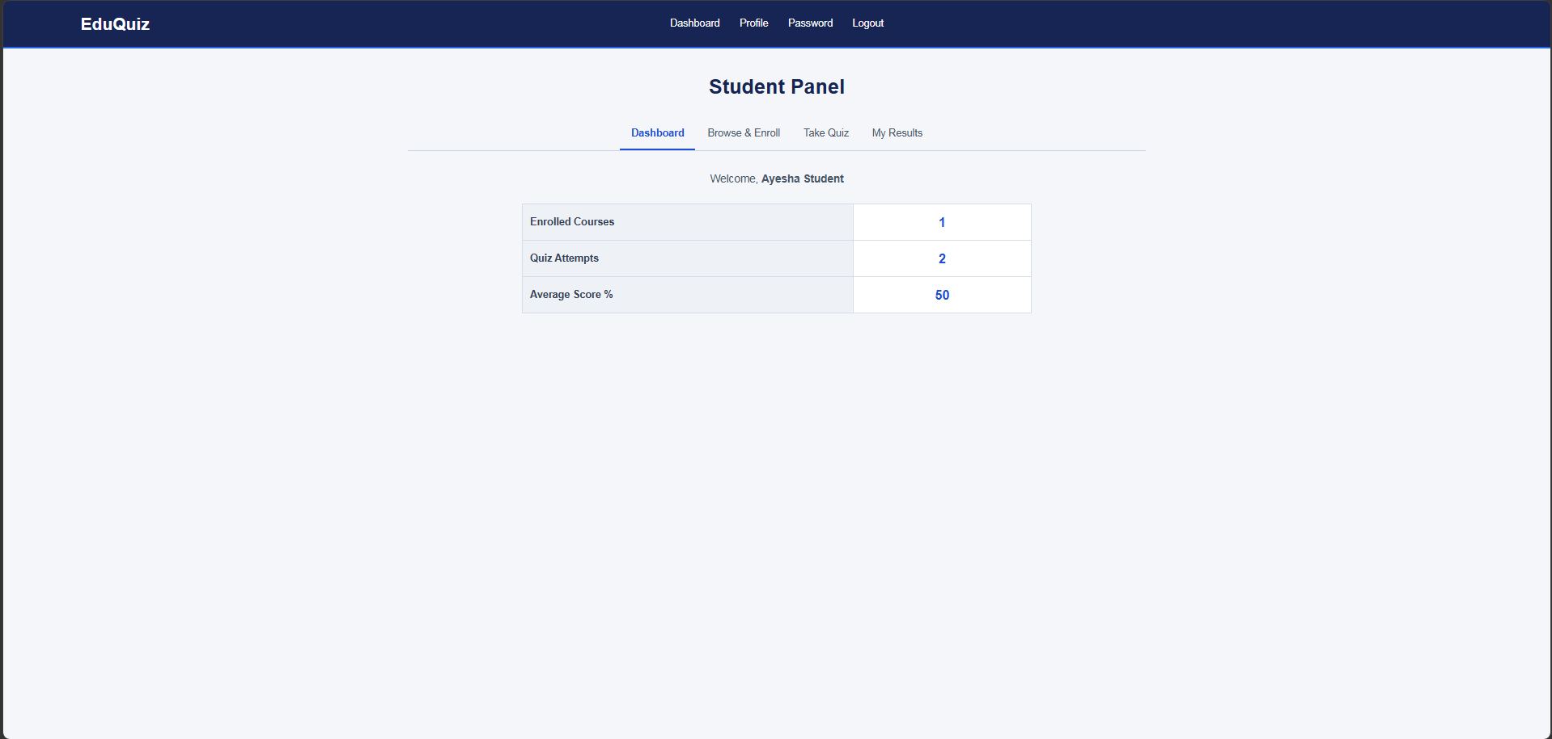

Types of User
- Admin
- Instructor
- Student

Common Features (Available to All Users)

Authentication
  - Login to the system
  - Logout from the system
  - User registration as Student or Instructor
  - Remember Me option during login

Account Management
  - Change or reset password
  - View profile information
  - Edit profile information
  - Delete account

Dashboard
  - Access a personalized dashboard after login

Additional Feature
  - AJAX-based username availability checking during registration

Specific Features by User Type

Features of Admin
  - Manage Student and Instructor accounts, including viewing, activating/deactivating, and deleting users.
  - View and manage courses available in the system.
  - View system-wide statistics such as students, instructors, courses, quizzes, and quiz attempts.

Features of Instructor
  - Create and manage their own courses.
  - Create multiple-choice quizzes and questions for courses.
  - View student quiz results, scores, and pass/fail status.

Features of Student
  - Browse available courses and enroll in them.
  - Attempt multiple-choice quizzes for enrolled courses.
  - View enrolled courses, quiz attempts, scores, average performance, and previous results.

